Photograph & Video Release Form

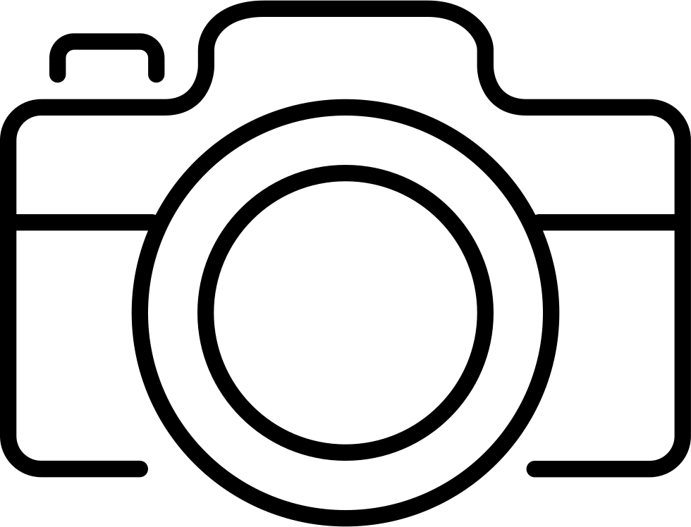
Pictureperfectnow Photography
The perfect picture, at the perfect time

I hereby grant pictureperfectnow Photography and any licensees, agents, and assignees thereof (collectively, “Photographer”) the perpetual, irrevocable, global and unrestricted right to use, reproduce, publish and copyright (collectively, "Use") my picture, likeness, and voice (collectively, "Image") in any media for publicity, art, advertising, trade, or for any other lawful purpose.
I understand that my Image may be substantially edited, altered, or modified. I hereby waive any right to inspect or approve Photographer's Use of my Image in any media.
I grant Photographer the right to market and sell copies of my Image. I also waive any right to royalties or other compensation related to Photographer's Use of my Image.
By signing this form, I acknowledge that I have completely read and fully understand the above release and agree to be bound thereby. I release Photographer and any legal representatives and assignees thereof from any claims in connection with the Use of my Image. I intend for this agreement to bind all of my heirs, assignees, personal representatives, and members of my family.

Full Name___________________________________________________________

Signature________________________________ Date______________________

If this release is obtained for a person under the age of 19, then the signature of that child’s parent or legal guardian is also required.

Parent’s Signature_________________________ Date______________________

